**VMware Horizon Monitoring**

The VMware Horizon View monitoring rule allows one to monitor VMware Horizon Protocol, Session & User Thresholds using our Goliath Intelligent Agent to alert on specified conditions in real-time.

By default, when the Horizon API is enabled, a monitoring rule named **VMware Horizon View - Session & Server Performance** will be created out of the box in which you can modify and enable for alerting.

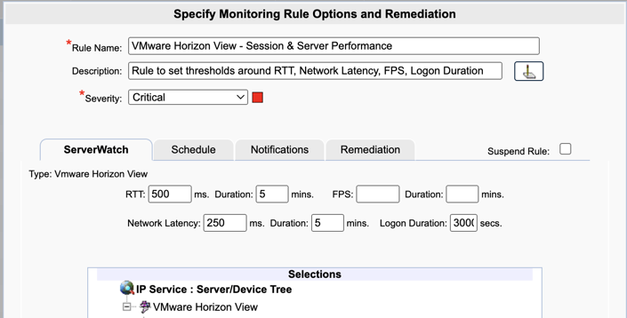

**Create a New Monitoring Rule**

1. To create a new monitoring condition, navigate to the **Configure - Monitoring Rules** page and click the **New** button
2. A selection pane will appear, select the radio button option for **VMware Horizon View** and then click **OK**
3. Now the monitoring rule pane will appear. At the top of the pane name the Monitoring Rule via the **Rule Name** field, as well as define the description and the severity.
4. The first tab, **ServerWatch** is where you will define condition(s) to be monitored.
   1. Note, only fields with values will be monitored. If you do not wish to monitor a particular metric do not enter a value in the field
   2. The monitoring rule will trigger on a per metric basis
5. **RTT** and **Duration:**Define the threshold for RTT and the duration value that needs to be exceeded in order to alert.
6. **FPS** and **Duration:** Define the threshold for FPS and the duration value that needs to be exceeded in order to alert.
7. **Network Latency** and **Duration:** Define the threshold for Network Latency and the duration value that needs to be exceeded in order to alert.
8. **Logon Duration:**Define the length of the logon threshold needed in order to alert.
9. In the **Selections** tree, select the VMware Horizon machines that you want to monitor the specified condition on
   1. Please note, a machine can only be applied to one VMware Horizon View monitoring rule type at a time. If there is no checkbox option, hover over the bell icon to get the name of the monitoring rule that the machine is currently applied to

**Configure the Schedule**

The **Schedule** tab of a monitoring rule allows users to define how frequently the rule will alert. This can be done by adjusting the following fields:

* **Alert Every Time**: Defines whether an alert is generated every time the conditions are on the previous tab are met.
  + When checked the alert is generated every time the conditions are met.
  + When unchecked, the alert is only generated if the alert conditions are met, and the Minimal Notification Interval is exceeded since the last alert for this type.
* **Minimal Notification Interval**: Defines the minimal interval that must elapse between events for this alert before another alert will be generated.
  + The Alert Every Time checkbox must be unchecked in order to use this option.
  + For ServerWatch IP Services, this also defines the minimum elapsed time since a service is first detected as down or failed before an alert is generated.
* **Maximum Notification Interval**: Defines the maximum number of times you want to be notified during a continuous failure situation.
  + A value of 0 means no maximum is defined so you will continue to be notified according to your Alert Every Time and Minimal Notification Interval settings.
  + A non-zero value means that after you have been notified the number of times defined in the Maximum Alert Notifications, and according to your Alert Every Time and Minimal Notification Interval settings, you will not be notified again.
* **Notify On Restore**: Defines whether a 'Restore' alert is generated if you have previously been alerted due to a failure.
  + There is always a Notify on Restore for a ServerWatch for IP Service
* **Service Check Frequency, Every**: Defines the frequency with which the service specified for this Monitoring Rule is checked. It is no recommended to do this check any fewer then 3 mins.
* **Alert 1st Time After X Failures:**Define a value 1 or greater that defines how many successive failures should occur before the 1st alert notification 'Action' is executed.
  + The **Alert Every Time** and **Minimum Notification Interval** settings do no become applicable until after this threshold setting is exceeded.
  + The default value for this setting is blank which means not applicable. When not applicable, the **Alert Every Time** and **Minimum Notification Interval** settings are active immediately and the 1st alert does not occur until the **Minimum Notification Interval** threshold is equaled or exceeded if it is active.

**Additional Configuration**

For additional configuration options please see the following articles:

* Enabling Notifications:
  + [Configure Email and Text Alert Notifications](https://support.goliathtechnologies.com/hc/en-us/articles/360024446933)
  + [Configure SNMP Alert Notifications](https://support.goliathtechnologies.com/hc/en-us/articles/360024726913)
  + [Configure Syslog Alert Notifications](https://support.goliathtechnologies.com/hc/en-us/articles/360024346594)
* [Configure Custom Remediation](https://support.goliathtechnologies.com/hc/en-us/articles/360024446633)